Project Design Phase
Solution Architecture
Date | 15 February 2026
Team ID | LTVIP2026TMIDS80893
Project Name | Rainfall Prediction System for Agriculture
Maximum Marks | 4 Marks

Solution Architecture Overview
The proposed Rainfall Prediction System follows a layered solution architecture that bridges agricultural business problems with a technology-driven predictive solution. The architecture consists of Presentation Layer, Application Layer, Processing Layer, Machine Learning Layer, and Data Storage Layer.
Users interact through a web interface. The Flask backend processes requests, applies preprocessing techniques, and invokes the trained Random Forest model. The system returns rainfall probability along with agricultural advisory recommendations.
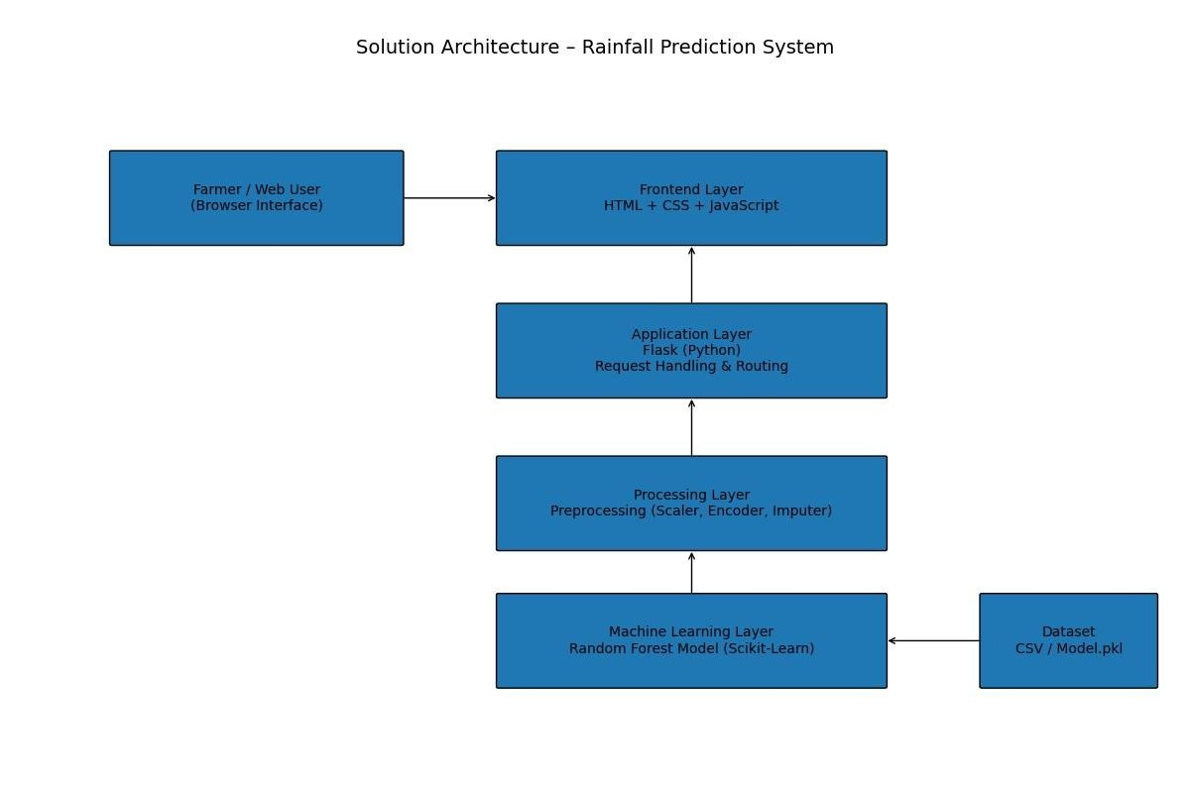

Architecture Characteristics
- Modular Design – Each layer performs a specific responsibility.
- Scalable Structure – Can be deployed on cloud platforms (AWS/Azure).
- Maintainable – ML model and preprocessing pipeline are stored separately.
- Extensible – Supports integration with real-time weather APIs in future.

Business–Technology Alignment
The architecture directly addresses rainfall uncertainty by converting historical weather data into actionable insights. The layered structure ensures reliability, fast prediction response, and clear separation between user interaction and model logic.

